Name: - Prajwal Shridhar Biradar
Team Members: - Ankita Sharma, Archit Dhodi, Anas Shaikh, Chesta Rawat, Harsh Burande.

Domain Chosen: - Entertainment Industry

Company: - Netflix

Presentation Date: - 15/12/2025



Product Dissection for Netflix
Company Overview:
Netflix, Inc. is a media company based in Los Gatos, California, that was founded in 1997 by American entrepreneurs Reed Hastings and Marc Randolph. The service is best known for allowing users to stream movies and television shows on a single platform, the company also releases its own works. Netflix initially gained popularity when it disrupted the Blockbuster video-rental model. The service has since challenged video streaming and cable companies, then content creators, and broadcasters. Netflix transitioned into a global streaming giant, offering a vast library of movies, TV shows, and original content. With its data-driven recommendation system and user-friendly interface, Netflix has become a leader in the streaming industry. It has over 300M+ subscribers in 200+ countries.
Product Dissection and Real-World Problems Solved by Netflix:
In the past, people relied on cable TV and DVDs for entertainment, which came with various limitations such as scheduled broadcasts, geographical restrictions, advertisements and high costs for physical media. With the rise of the internet, the demand for on-demand streaming services grew, leading to the emergence of platforms like Netflix. Netflix fulfils this demand by providing a seamless, on-demand entertainment experience, eliminating the need for traditional cable subscriptions and physical media purchases. With this one can watch whatever one wishes to watch in the present moment with easy access.
Netflix offers:
- Instant access to content without waiting for downloads or broadcasts.
- Personalized recommendations based on user preferences.
- Global accessibility with multi-language support and regional content.
- Flexible viewing options, including offline downloads and multiple device support.
- Cost-effective entertainment with different pricing tiers for various user needs.

How Netflix Solves Real-World Problems: -
Netflix, as a leading streaming platform, has effectively tackled various real-world challenges through its innovative features. By leveraging advanced algorithms, Netflix enhances content discovery, provides personalized recommendations, and ensures seamless viewing experiences. Its focus on user engagement and accessibility has positioned it as a household name worldwide.
Technological Infrastructure and Resilience: Netflix's commitment to system robustness is exemplified by its development of the "Simian Army", a suite of tools designed to intentionally introduce failures into its system. This proactive strategy ensures the platform's resilience against unexpected issues, maintaining high availability and reliability for users.
Scalability and Innovation through Cloud Services: Leveraging Amazon Web Services (AWS), Netflix has built a scalable and flexible infrastructure that supports its vast global user base. This cloud-based approach facilitates efficient data management and rapid deployment of new features, fostering continuous innovation. It uses different databases for different purposes: Apache Cassandra is used for high-scale level, writes-intensive tasks like storing viewing history. MySQL and CockroachDB handle financial transactions and billing.
Personalized User Experience: Netflix employs advanced algorithms to analyze user behaviour, delivering personalized content recommendations. This focus on personalization enhances user engagement and satisfaction, setting it apart from its competitors. It uses Data Lake architecture to store and process billions of user interactions per day to power recommendation engines.
Evolution of Product Vision: Transitioning from a DVD rental service to a streaming giant, Netflix's product vision has evolved to emphasize original content and global accessibility. This strategic shift has allowed Netflix to expand its market presence and cater to diverse audience preferences.
Data-Driven Decision Making: Netflix's culture of experimentation and data analysis informs its product development and content creation strategies. By understanding viewer habits and preferences, Netflix continually refines its offerings to align with user expectations.
These strategic initiatives underscore Netflix's ability to adapt and innovate, maintaining its leadership in a competitive streaming landscape.

Case Study: Real-World Problems and Netflix's Innovative Solutions
Netflix’s success lies in its ability to understand what viewers want and to solve user-centric problems using technology and data. Below are some key issues it addresses:
Problem 1: Content Discovery and Overload
Challenge:
With thousands of TV shows, movies, and documentaries available, users often struggle to find something engaging to watch. The sheer volume of content can lead to decision fatigue, and confusion where users spend more time browsing than watching.
Netflix’s Solution:
AI-Powered Collaborative Filtering:
Netflix analyzes user’s watch history, search patterns, and viewing habits to suggest content tailored to their interests. It uses machine learning algorithms like collaborative filtering, deep learning models, and behavioural clustering to predict user preferences. It also provides personalized recommendations like:
- “Because You Watched” section suggests similar content based on previous views.
- “Trending Now” highlights popular content worldwide.
- “Top Picks for You” curates personalized movies and shows recommendations.
- “Continue Watching” helps users quickly resume where they left off.
- “My List” saves shows, movies, or documentaries one wants to watch later.
Netflix offers genre-based categorization, mood-based suggestions, and hidden categories that help users discover niche content.
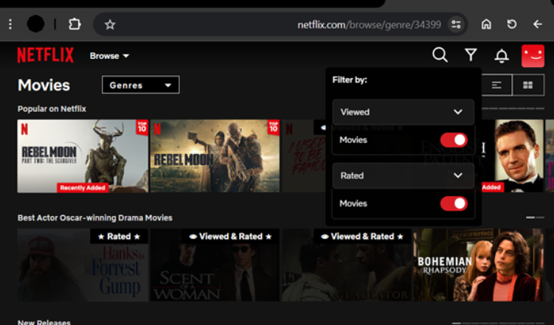

Problem 2: Streaming Interruptions Due to Network Issues
Challenge:
Users with slow internet connections or fluctuating bandwidth experience buffering, lag, and reduced video quality, making the viewing experience frustrating.
Netflix’s Solution:
Adaptive Bitrate Streaming (ABR):
Netflix dynamically adjusts video quality based on the user’s internet speed. If the connection slows down, Netflix automatically reduces the resolution (e.g., 4K → 1080p → 720p→ 420p) instead of pausing the video. It stores frequently accessed content closer to users using distributed servers worldwide. This reduces loading times and improves streaming quality. Uses Open Connect, Netflix’s custom-built CDN, to optimize data transfer speeds. Users can download movies and TV shows to watch without an internet connection. Downloaded content automatically adjusts quality based on storage capacity and available bandwidth.

Problem 3: Personalized Viewing for Multiple Users
Challenge:
In a shared household, different users have distinct preferences, leading to a cluttered viewing experience. Parents may want drama and thrillers, while children prefer animated content.
Netflix’s Solution:
It allows up to 5 profiles under one account, ensuring that each family member gets personalized recommendations, watch history, and preferences. It provides Kids' Mode & Parental Controls, the dedicated Kids' profiles restrict content to age-appropriate shows and movies. Also, parents can block specific content or restrict access to mature content via password-protected settings.
Lastly each profile saves progress, so users can switch devices without losing their place. A profile can track watched episodes, favorite genres, and preferred language settings.
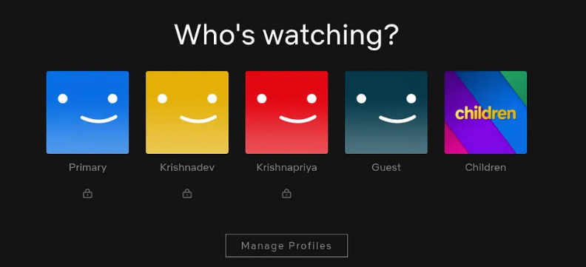

Problem 4: Preventing Content Piracy and Unauthorized Access
Challenge:
Illegal streaming, piracy and password sharing significantly impact Netflix’s revenue. Many users share their credentials, leading to unauthorized access and revenue loss.
Netflix’s Solution:
It is one of the most commonly faced challenges by streaming platforms. To solve this Netflix encrypts content to prevent illegal downloads and unauthorized distribution. DRM (Digital Rights Management) ensures that only authorized users can stream the content. It has introduced IP-based tracking and device monitoring to detect password sharing, verification codes are sent via email or SMS to confirm the primary account owner. Plans like Netflix Household require users to verify their home network for Account-Sharing Limits & Verification purposes.

Problem 5: Limited Accessibility & Customization for Different Viewers
Challenge:
Many streaming services do not cater to people with hearing impairments, visual impairments, or non-native language speakers. Without accessibility features, many users struggle to understand or fully enjoy content.
Netflix’s Solution:
Netflix enhances accessibility with advanced captioning and audio description features. Protagonist View Captions focus on main character dialogues, minimizing background noise distractions—ideal for language learners and those preferring a streamlined experience. Narration View (Audio Descriptions) assists visually impaired users by providing detailed scene and character action descriptions between dialogues. Additionally, Captions & Subtitles are available in over 20 languages with customizable font, size, and colour, ensuring a more inclusive and personalized viewing experience.
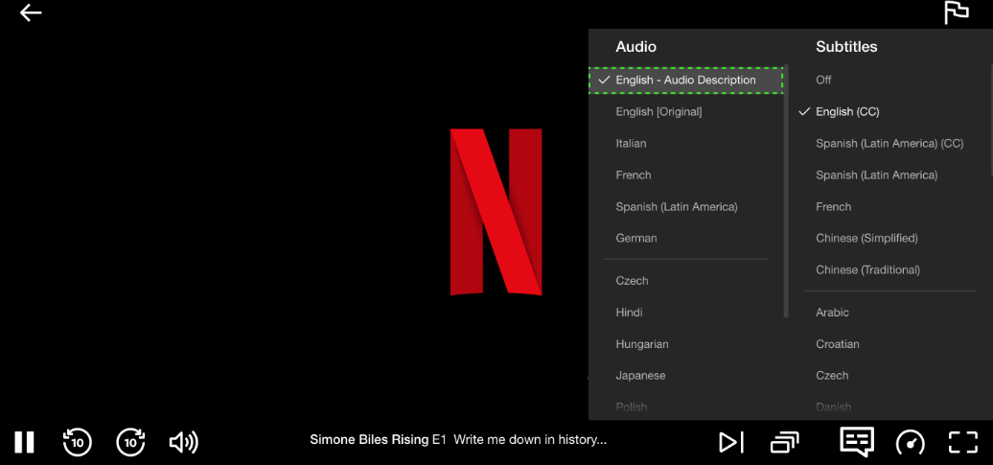
Top Features of Netflix:
- User Profiles: Allows users to create profiles, log in securely, and provides separate personalized viewing experiences for multiple users under one subscription.
- AI-Powered Recommendations: Machine learning algorithms suggest content based on viewing history. It uses a combination of algorithms that blends collaborative filtering, content-based methods, and deep learning with contextual & ranking algorithms.
- Watch History & Resume Watching: Tracks viewing progress for seamless experience. Can continue from where one left on any of the devices with activated id.
- Subscriptions & Payments: Offers flexible pricing plans (Basic, Standard, Premium) as per uses requirement.
- Ratings & Reviews: Users can like/dislike content, refining recommendations. This helps to provide better suggestions as per user’s liking.
- Offline Viewing: Allows downloads for watching without an internet connection, so that users can watch movies/series without internet connectivity.
- Global Accessibility: Multi-language support with subtitles and dubbing, different view options. This helps to cover a large population of audience.
- Content Catalog Management: Efficiently managing a vast library of movies, TV shows, documentaries, and original content.
- Search and Navigation: Provides intuitive search functionality and navigation to help users discover content easily.

Schema Description: -
User Entity:
- User_ID (PK): Unique identifier for each user.
- Username: User's login username.
- Password: User's password (stored securely, typically hashed).
- Email: User's email address for communication.
- Subscription_plan_id: Reference to the user's subscription plan.
- Region (VARCHAR 50): The user's geographic region (e.g., Asia, Europe, US) for sharding.
- Status (VARCHAR 20): Account status (e.g., Active, Cancelled) for churn analysis.
Subscription Plans:
- Plan_id (INT, PK): Unique ID for each subscription plan.
- Plan_name (VARCHAR 50): Name of subscription plan (Basic, Standard, Premium).
- Price (DECIMAL(5,2)): Price of the plan.
- Max_streams (INT): Number of simultaneous streams allowed.
- Resolution (VARCHAR 20): Max video resolution supported.
Profiles:
- Profile_id (INT, PK): Unique ID for user profile.
- User_id (INT, FK): Refers to the owning user.
- Profile_name (VARCHAR): Name of the profile (e.g., Kids, Default).
Content Entity:
- Content_ID (PK): Unique identifier for each content item.
- Title (VARCHAR 255): Title of the movie, TV show, or documentary.
- ReleaseDate (DATE): Release date of the content.
- Duration (INT): Duration of the content in minutes.
- Rating (VARCHAR 10): Content rating (e.g., PG-13, UA).
- Description (TEXT): Brief description of the content or information about content.
- View_Count (BIGINT): Total number of times the content has been watched.
Genres:
- Genre_id (INT, PK): Unique genre ID.
- Genre_name (VARCHAR 50): Name of the genre (Action, Comedy).
ContentGenres:
- Content_id (INT, PK part 1, FK): Refers to content.
- Genre_id (INT, PK part 2, FK): Refers to genre.
UserContentInteraction:
- Interaction_id (INT, PK): Unique interaction ID.
- User_id (INT, FK): User performing interaction.
- Content_id (INT, FK): Content item being interacted with.
- Interaction_type (VARCHAR): Type like watched, rated, added to watchlist.
- Interaction_date (TIMESTAMP): When interaction occurred.
- Timestamp_Progress (INT): Saved playback position in seconds (for "Continue Watching").
Watchlist:
- Watchlist_id (INT, PK): Unique watchlist entry ID.
- User_id (INT, FK): User who owns this watchlist entry.
- Content_id (INT, FK): Watched content item.

Artists:
- Artist_ID (INT, PK): Unique identifier for an actor or director.
- Name (VARCHAR 100): Full name of the artist.
ContentArtists:
- Content_ID (INT, FK): Refers to the Content entity.
- Artist_ID (INT, FK): Refers to the Artists entity.
- Role (VARCHAR 50): Role in the production (e.g., Actor, Director, Writer).
Payments:
- Payment_ID (INT, PK): Unique transaction ID.
- User_ID (INT, FK): Refers to the User entity (user making the payment).
- Amount (DECIMAL 10,2): Transaction amount.
- Payment_Date (TIMESTAMP): Date and time of payment.
- Payment_Status (VARCHAR 20): Status (e.g., Success, Failed, Refunded).
AuditLogs:
- Log_ID (BIGINT, PK): Unique log entry ID.
- User_ID (INT, FK): Refers to the User entity.
- Content_ID (INT, FK): Refers to the Content entity (if applicable).
- Action_Type (VARCHAR 50): Type of action (e.g., Login, Stream_Start, Download).
- IP_Address (VARCHAR 45): User's IP address for security tracking.
- Timestamp (TIMESTAMP): Exact time of the event.

Relationships:
In a relational database for Netflix applications, entities are interconnected through relationships, defining how data in one entity is related to data in another. Common relationships includes:
User-Content Relationship (via UserContentInteraction)
- Many-to-many.
- Each user can interact with multiple content items:- movies,shows etc.
- Each content item can be interacted with by multiple users.
- This relationship is captured by the UserContentInteraction table, which includes a record for every user’s action regarding specific content.

User-Watchlist Relationship
- Many-to-many.
- One user can add multiple content items to their watchlist.
- Each content item can appear on the watchlists of many users.
- The Watchlist table connects users and content, recording which user has which content in their watchlist.
Content-Genre Relationship
- Many-to-many.
- One content item can have multiple genres (e.g., Horror, Thriller).
- Each genre is associated with multiple content items.
- This association is maintained through the ContentGenres table which links content with genres.
User-Profile Relationship
- One-to-many.
- One user account can create and manage multiple profiles (e.g., for children, family members,friends).
- Each profile belongs to exactly one registered user.
- This is handled by the foreign key from Profiles to Users.
User-Subscription Plan Relationship
- Many-to-one.
- Many users can subscribe to the same subscription plan (e.g., Basic, Premium).
- Each user has only one active subscription plan, can’t have multiple subscriptions at a time.
- This is modeled by the subscription_plan_id foreign key in the Users table referencing the SubscriptionPlans table.

Functional Insights:
- Users maintain profiles allowing personalized collections and recommendation
under a single subscription.
- Content is categorized under multiple genres to facilitate browsing and
filtering.
- User interactions with content allow the system to track views, ratings, and user preferences.
- Watchlists enable users to save content for later viewing.
- Subscription plans control user access and capabilities like concurrent streams and video quality.
ER Diagram:
An Entity-Relationship Diagram is the visual representation of entities, attributes, and relationships in a database system. It is commonly used in database design to structure data logically. It gives an understanding of key components present in the database and how they are related to each other.

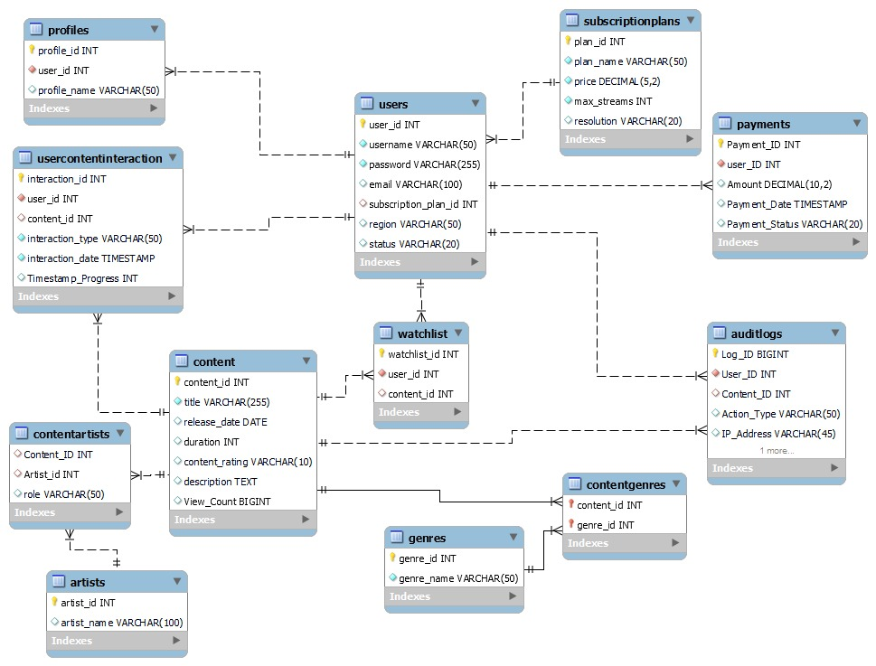

Revenue and Profit Growth Strategies
Question: After completing the product dissection and schema design steps for the chosen platform, conduct a comprehensive case study on the above chosen industry. Your goal is to identify and propose strategies to increase the profit of the industry by at least 25%.
Create a detailed report summarising your findings and proposals. Include data-driven justifications for each proposed strategy and present your case study using visual aids such as charts, graphs, and diagrams to illustrate your points. Outline the steps, resources, and timeline required to achieve the desired revenue and profit growth.

In a world where streaming has become the default mode of content consumption, OTT platforms are transforming how audiences engage with media, education, sports and business communication. From Netflix to YouTube to specialized niche apps, every brand now seeks a digital platform to connect, inform, and entertain.
Netflix, being the world’s largest OTT streaming platform, operates across 190+ countries with over 260M+ paid subscribers. While Netflix has achieved strong global dominance, further profit growth of 25% can be achieved through content optimization, new monetization models, and data-driven personalization.
Strategies are: -
- Expansion of Ad-Supported Streaming Tier
- Strategy
  - Scale the ad-supported plan globally.
  - Introduce premium ad slots, regional advertisers, and tiered ad packages.
  - Focus on unlocking high-margin advertising revenue.
- Justification
  - Ad-supported plans have higher profit margins than
subscription-only models.
  - Netflix’s ad tier is growing rapidly and drives a large share of new signups.
  - Premium ads during hit shows can command 3–5× higher CPMs.
  - Global advertisers prefer OTT platforms due to higher engagement compared to traditional TV.

- Global Pricing Optimization & Subscription Bundles
- Strategy
  - Introduce country-specific pricing models.
  - Offer annual subscription discounts.
  - Launch family plans, student packs, and gaming + streaming bundles.
- Justification
  - Purchasing power varies across countries; uniform pricing
increases churn in price-sensitive markets.
  - Annual plans improve retention and reduce marketing and acquisition costs.
  - Family and student bundles expand the user base without increasing infrastructure costs.
  - Bundling gaming increases cross-platform usage and improves ARPU.
- Merchandise, Licensing, and Live Experiences
- Strategy
  - Expand Netflix’s consumer merchandise offerings.
  - Launch tours, exhibitions, and live experiences around popular shows.
- Justification
  - Merchandise generates high margins (approximately 20–30% incremental profit).
  - Licensing provides recurring revenue without additional
production costs.
  - Live experiences improve brand stickiness and add non-subscription income streams.
- AI-Driven Personalization & Churn Reduction
- Strategy
  - Deploy advanced machine-learning models for:
    - Personalized recommendations
    - Churn prediction
    - Targeted retention and win-back offers
- Justification
  - Around 80% of Netflix viewing is driven by personalized recommendations.
  - Reducing churn by even 1–2% significantly increases profitability.
  - Targeted win-back offers reduce customer acquisition costs.
  - Improved recommendations increase watch time, which raises ad inventory value.
- Freemium Plans with Ad-Supported First Episodes
- Strategy
  - Introduce a freemium tier allowing users to watch:
    - First episodes of new series
    - Pilot episodes
    - Selected catalog movies
    - Top-performing Netflix Originals
  - Offer content free with ads, without requiring account creation.
- Justification
  - Platforms like YouTube and Amazon miniTV show strong success with ad-supported free content.
  - First episodes have the highest conversion potential once users are engaged.
  - High-traffic free content attracts premium advertisers.
  - Ad revenue increases without adding content production costs.
- Sports & Live Events Streaming
- Strategy
  - Expand into sports and live event streaming.
  - Acquire selective broadcasting rights for cricket, football, and entertainment events.
  - Enter through strategic partnerships following JioHotstar’s exit from ICC streaming rights.
  - Use a hybrid monetization model:
    - Subscription upgrades
    - Premium ad slots
    - Event-based passes

- Justification
  - Live sports attract the highest global viewership and increase daily active users.
  - Sports streaming delivers unmatched engagement, boosting ad revenue.
  - Event-based passes create new revenue without long-term subscription changes.
  - Live content builds habit-forming usage patterns and reduces churn.
  - International sports (cricket, tennis, F1, football) strengthen Netflix’s positioning as a complete entertainment ecosystem.
Summary Table :-

Strategy | Projected Growth | 2026 | 2027 | 2028
Ad-Supported Tier Expansion | +9-11% | +2.5-3% | +3-3.5% | +3.5-4.5%
Pricing Optimization | +4.5–6.5% | +1-1.5% | +1.5-2% | +2-3%
Merchandise & Licensing | +3–5% | +0.5%-1% | +1-1.5% | +1.5-2.5%
AI Personalization & Retention | +1.75–3.5% | +0.25-0.5% | +0.5-1% | +1-2%
Freemium Content Sampling | +3–4.5% | +0.5-1% | +1-1.5% | +1.5-2%
Sports & Live Events | +3.5–6% | +0.5-1% | +1-2% | +2-3%
Total Potential Growth | ≈ 25–36.5% | ≈ 5.25-8% | ≈8-11.5% | ≈11.5-17%

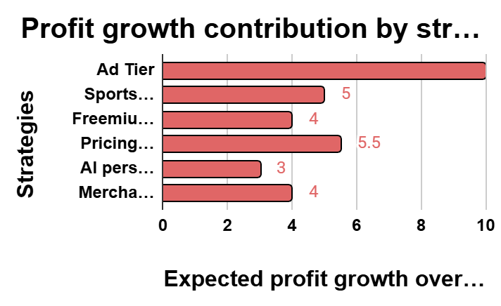
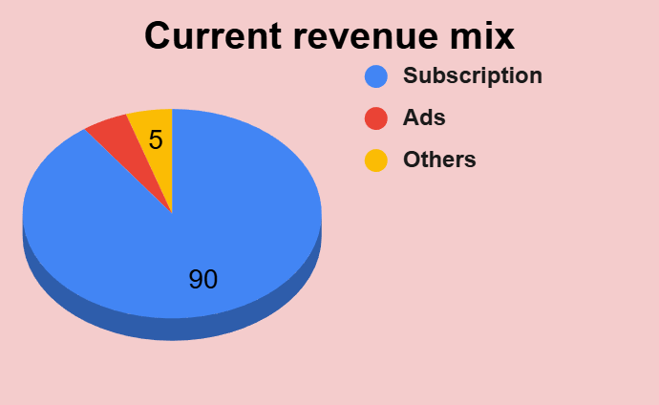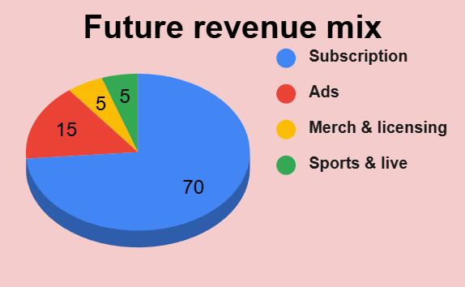

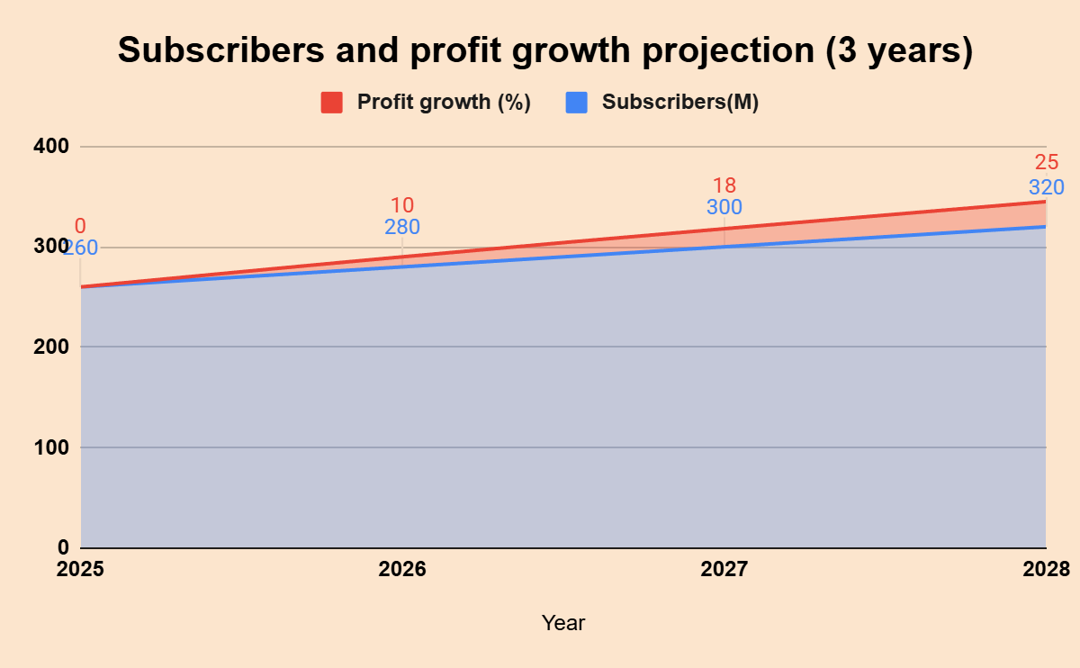
Conclusion :-
Netflix has already established itself as the global leader in OTT streaming, but sustaining growth requires diversification beyond traditional subscription models. By expanding ad-supported tiers, optimizing pricing, investing in merchandise/licensing, leveraging AI-driven personalization, and entering sports/live events, Netflix can unlock new revenue streams while reducing churn.
The combined impact of these strategies is projected to deliver 20–25% profit growth within 3 years, aligning with consumer trends and strengthening Netflix’s position as a complete entertainment ecosystem.
In summary, Netflix’s path to higher profitability lies in:
- Monetization innovation (ads, freemium, bundles).
- Content expansion (localized originals, sports, live events).
- Ecosystem building (gaming, merchandise, experiences).
- Data-driven personalization (AI for retention and engagement).
This multi-pronged approach ensures sustainable growth, competitive differentiation, and long-term shareholder value.

Netflix Guesstimates

BIG PICTURE
 | Approx. Percentage | Approx. Users
Population | - | 8 Bill
Global Internet Penetration | 70% | 5.5 Bill
OTT users | 90% | 5 Bill
Netflix global market share | 6% | 300 Mill

Q1) What will be the percentage increase in global streaming service subscriptions of Netflix over the next five years?

A1) Below is the approximate data of last 6 years:-
Year | Subscribers in Million (approx.) | % increase
2019 | 160
2020 | 200 | 25
2021 | 220 | 10
2022 | 230 | 5
2023 | 260 | 13
2024 | 300 | 15
2025 | 310 | 3
 | approximate CAGR of past 5 year | 9

We can say that there has been an average of 9% increase in subscribers each year for the last 5 years.
By keeping the above numbers in consideration, we can guess that: -
 | By the year | expected subscribers in million with ~9% increase/year
 | 2025 | 310
 | 2026 | 338
 | 2027 | 368
 | 2028 | 401
 | 2029 | 437
 | 2030 | 476
Netflix would be having approximately 470 million subscribers
That is nearly 50% of the year 2025

300 Million Users
0-16 age group |  | 17 - 50 age group |  |  | 51 - 70+ age group
~ 5% |  | ~80% |  |  | ~15%
~30min/per/day |  | ~90min/per/day |  |  | ~30min/per/day
Sum of watch time of 3 groups |  |  |  |  |  | ~2.5 hours a day
per day | (30min | 90min |  | 30min)
Weekly watching by 3 groups |  |  |  |  |  | ~20 hours a week
(~2.5 hours * 7 days ~ 18 hours + 2 hours extra on weekend)
Hours spend by per person per week is |  |  |  |  |  | ~6.5 hrs
Q2) How many hours of content will the average person consume per week through digital platforms in 2025?

We can assume that a person spends approximately ~6.5 hours on Netflix per week.

Q3) How many new films and TV shows will be produced globally per year by Netflix by 2030?

- Let’s assume Netflix launches 22 shows per month, which turns out to be ~260 shows a year, which serves as the baseline for this projection.
- And if we consider the annual growth rate of 5%, 10%, 15% and 20% in the number of shows released a year on Netflix, we can say:
- We modeled future output using four growth scenarios: 5%, 10%, 15%, and 20% CAGR.
- These scenarios represent different strategic possibilities—from conservative growth to aggressive global expansion.
- Under these assumptions, Netflix’s 2030 annual production is projected to range between 332 and 647 titles.
- The 15% growth scenario emerges as the most realistic, estimating ~524 new titles per year by 2030.

Year | 5% rise | 10 % rise | 15% rise | 20% rise
2025 | 260 | 260 | 260 | 260
2026 | 273 | 286 | 299 | 312
2027 | 287 | 315 | 344 | 374
2028 | 301 | 347 | 396 | 449
2029 | 316 | 382 | 455 | 539
2030 | 332 | 420 | 523 | 647
TOTAL | 1769 | 2010 | 2277 | 2581

Q4) What percentage of Netflix’s total global revenue will be contributed by international markets over the next five years?
A4)
Netflix’s most popular plan around the world has an average price of $12 - $14 per month.
- Let’s consider the base line as $10 per month per subscriber across the world.
- Netflix has ~300M subscribers. Consider 80% as active users.
- So,
  - $10 * 12months = ~$120/user/year
  - $120 * 240M subscribers = 28.8B = ~30B
- Netflix, with its most popular plan, yearly makes approximately $30B globally.
  - Let’s consider, Netflix has its major share of ~30% in the USA/Canada region.
  - Rest 70% is all its global market
    - $30B * 70% = ~$21B (for 2025)
- Now, by considering 9% growth in the customer base every year
  - By the year 2030, Netflix would be having 470M subscribers.
  - 80% of 470M = ~376M = 376M active users.
  - Also consider the $10 plan becomes a $15 plan by the year 2030.
  - So,
    - $15 * 12 months = $180/user/year
    - $180 * 375M = ~$67B
    - $67B * 70% = ~$47B
By 2030, Netflix is projected to generate approximately $47 billion annually from its international markets.

Q5) What will be the market share of virtual reality (VR) and augmented reality (AR) entertainment experiences in the next decade?
A5)
By referring to the previous question, we know that in the year 2025 we will have ~300M subscribers & revenue of ss while the average plan price increases by $1 annually. So,

Year | Users in million (9% increase) | avg. plan price ($) | annual revenue in billion (approx.) | AR/VR growth per 5 year | AR/VR share (billion)
2025 | 300 | 120 | 35 | 0.3% | ~0.10
2030 | 470 | 180 | 80 | 0.8% | ~0.65
2035 | 700 | 240 | 170 | 1.5% | ~2.50

- Assuming Netflix’s revenue grows from ~$35B in 2025 to ~$170B by 2035.
- AR/VR adoption increases gradually from 0.3% to ~1.5% over the same period.
- AR/VR-related revenue could grow from ~$100M to over $2.5B annually by 2035.

Scenario-Based Questions:
Scenario-Based 1
Question 1
How would you calculate the monthly retention rate for each cohort of users who signed up in different months?
The goal is to measure how user retention changes month-over-month across different sign-up cohorts to identify early churn patterns and improve subscriber lifetime value.
Understanding Cohorts
SELECT cohort_month,
month_number,
COUNT(user_id) AS active_users,
COUNT(user_id) * 100.0 / initial_cohort AS retention_rate
FROM retention_table
GROUP BY cohort_month, month_number;

Users grouped by their sign-up month
Cohorts:
Cohort Name | Sign-Up Period | Initial Users
January 2024 | Jan 1-31, 2024 | 1,000
February 2024 | Feb 1-29, 2024 | 1,200
March 2024 | Mar 1-31, 2024 | 1,500
April 2024 | Apr 1-30, 2024 | 1,100

Step 1: Define Your Cohorts
Group all users by the month they signed up for the subscription.
Example:
- All users who signed up in January 2024 = January Cohort
- All users who signed up in February 2024 = February Cohort
Step 2: Track Time Periods
Define the timeline for each cohort:
- Month 0: Sign-up month (baseline = 100%)
- Month 1: First month after sign-up
- Month 2: Second month after sign-up
- Month 3: Third month after sign-up
- And so on...
Step 3: Count Active Users
For each month, count how many users from the original cohort still have active subscriptions.
Active Subscription means:
- User has paid for the current month
- Account is not cancelled
- Subscription status = "Active"
Step 4: Apply the Retention Formula
Monthly Retention Rate = (Active Users in Month N / Initial Cohort Size) × 100

- Active Users in Month N = Number of users still subscribed in that specific month
- Initial Cohort Size = Total number of users who signed up in the cohort's month
- × 100 = Converts decimal to percentage
January 2024 Cohort Analysis
Initial Data:
- Sign-up Month: January 2024
- Initial Users: 1,000 users
Tracking Over Time:

Time Period | Active Users | Calculation | Retention Rate
Month 0 (Jan) | 1,000 | 1,000 / 1,000 × 100 | 100%
Month 1 (Feb) | 950 | 950 / 1,000 × 100 | 95%
Month 2 (Mar) | 890 | 890 / 1,000 × 100 | 89%
Month 3 (Apr) | 830 | 830 / 1,000 × 100 | 83%
Month 4 (May) | 800 | 800 / 1,000 × 100 | 80%
Interpretation:
- Month 1: 95% retained → 5% churned (50 users cancelled)
- Month 2: 89% retained → 6% churned in this month (60 users)
- Month 3: 83% retained → 6 % churned in this month (60 users)
- Month 4: 80% retained → 3% churned in this month (30 users)
Key Insight: The highest drop-off occurs in the first 3 months!
Question 2: If users tend to drop off after the third month, what strategies would you propose to improve long-term retention?
Understanding drop-off patterns helps Netflix design powerful retention strategies that re-engage users, extend their subscription period, and reduce churn before it happens.
Root Causes of Drop-Off (Likely):
• Weak onboarding experience
• Low perceived value after trial
• Inconsistent content relevance
• Competitor switching

Month | Active User | Retention Rate | Monthly Drop-Off
Month 0 | 1000 | 100% | -
Month 1 | 850 | 85% | 150 Users
Month 2 | 720 | 72% | 130 Users
Month 3 | 650 | 65% | 70 Users
Month 4 | 600 | 60% | 50 Users
Insight: The highest drop-off occurs around Month 2 and Month 3, indicating this is the most critical period for retention interventions.

Strategies to Improve Long-Term Retention After Month 3:
1. Hyper-Personalized Recommendations (Most Effective Strategy)
Netflix’s recommendation engine drives 80% of watch activity, making it the #1 retention driver.
What it includes:
- “Because You Watched…” categories
- Tailored genre mixes
- Personalised home page for each user
2. Exclusive Content & Timed Releases (High Impact)
OTT platforms retain users when they release high-quality originals and weekly episodes around critical churn periods.
Effective examples:
- Netflix Originals (Money Heist, Stranger Things)
- Releasing new seasons in monthly cycles
- Week-by-week episode drops to maintain engagement

3. Targeted Win-Back Campaigns (Highly Result-Driven)
Personalised reactivation messages sent to users who show signs of churn.
Techniques:
- Email/push: “New season of your favourite show is live!”
- Alerts for watchlist items releasing
- Reminders about popular trending titles
4.Loyalty Incentives After Month 3 (Churn-Reduction Strategy)
Since most churn occurs around the 3rd month, strategic incentives are powerful.
Effective incentives:
- 20–30% discount for Month 4 renewal
- Early access to premium shows
- Watch-time rewards (points redeemable for credit)
- Special “loyal subscriber” perks

Scenario 2: A/B Test for Tutorial Designs
Question 1: Design an A/B test to evaluate which tutorial version (A: text-based, B: interactive)x leads to better retention and conversion rates. What metrics would you use?
A/B Test Design
To determine which tutorial performs better, new users will be randomly split into two groups:
- Group A: Sees the text-based tutorial
- Group B: Sees the interactive, step-by-step tutorial
Both groups will then be tracked for 7 days to compare retention and conversion outcomes.
suppose 2,000 new users join the game:
- 1,000 users get Version A
- 1,000 users get Version B
After 7 days, we measure:
Metric | Version A | Version B
Day-7 Retention | 40% (400 users return) | 55% (550 users return)
Day-7 Conversion | 5% (50 users purchase) | 8% (80 users purchase)
Interpretation:
- Version B keeps more players (55% vs 40%)
- Version B generates more purchases (8% vs 5%)
Summary:
To evaluate which tutorial works best, run an A/B test by showing Version A to half of the new users and Version B to the other half. Track retention and conversion for 7 days. If Version B shows higher Day-7 retention and more purchases as in the example- then Version B is the better option and should be implemented.
Question 2: Balancing Higher Conversion vs Slightly Lower Retention:
If Version B (interactive tutorial) yields higher conversion rates but slightly lower retention, we need to weigh the short-term gains vs long-term value. The decision should consider overall business goals (revenue, lifetime value, user experience).

- Revenue per user: Higher conversion means more users paying quickly → good for cash flow.
- Lifetime value (LTV): Lower retention may reduce total time a user remains active → could lower long-term value.
- Churn cost: If many users leave soon after converting, acquisition + onboarding costs may outweigh benefit.
- User experience and brand perception: Users who convert then drop out may have poor experience — might hurt reviews/referrals.

Recommendation & Strategy (Balanced Approach)
- Adopt Version B (since conversion is higher), but refine it to improve retention. Don’t accept retention drops as permanent.
- Run a second iteration / experiment: Keep interactive tutorial, but add retention-focused tweaks (e.g. provide early rewards, recommend next-step content, onboarding nudges).
- Monitor both metrics long-term — not just conversion but retention at 1 month, 3 months, maybe 6 months.
Hypothetical Results
Suppose:
- Version B: 8% conversion within 7 days, but Day-30 retention = 45%
- Version A: 5% conversion, but Day-30 retention = 55%
If you assume average revenue per paying user is ₹100, and average lifetime months for retained users is higher in A — it’s not immediate that B is better overall.
However:
- If Version B converts more users, even if a fraction churn, your short-term revenue increases.
- If you then improve retention (via tweaks), you get both — more users and longer engagement, maximizing revenue.
Recommendation
I recommend rolling out Version B as a primary tutorial, because its higher conversion accelerates monetization. Simultaneously, implement retention-enhancing refinements (onboarding nudges, first-purchase bonuses, follow-up engagement triggers). This balanced approach leverages Version B’s strength while aiming to match — or exceed — the retention levels of Version A, maximizing long-term value.

DBMS:
ACID:
1.Netflix enforces that for any show, a user must only have one active “Continue Watching” entry. When the user finishes Episode 5 and moves to Episode 6, how does the database guarantee that the old entry disappears and only the new one is shown?

A constraint (such as a UNIQUE rule on user_id + content_id) ensures that only one “in-progress” entry can exist per user per show.
When Episode 6 is added, Episode 5 must be removed in the same transaction.
This ensures the database never ends up in an invalid state where both episodes appear simultaneously in Continue Watching.

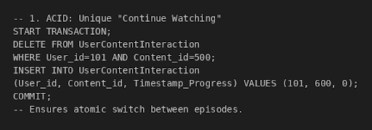

2.Preventing Conflicts in Watch Progress Updates
When two devices belonging to the same Netflix user try to update the watch progress of a show at the same time, how does the system prevent them from overwriting each other’s progress or saving inconsistent timestamps?

The database isolates each update so that concurrent progress changes do not interfere.
Only one update is allowed to modify the progress record at a time, preventing lost updates.
Internal locking or concurrency control ensures that each device’s update operates on a consistent snapshot of the data.
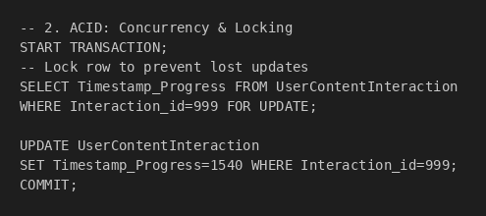

Indexing:

3.Your platform offers search by actor name, genre, and language. How would you use indexing to improve query response times for search results?

By creating indexes on genre_name and linking them through contentgenres allows the system to instantly fetch all content belonging to a selected genre.
Full-text indexing on title or description supports fast keyword searches, helping users find movies by keywords or partial matches without slow wildcard scans.
Composite indexing on (genre_id, content_id) inside contentgenres improves join performance when filtering by multiple attributes.

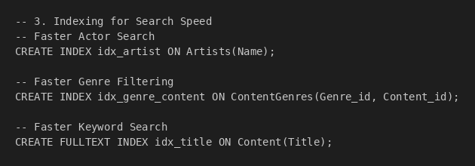

4.The view count for each movie is updated frequently. Would you index this column? Why or why not?

The view_count field updates very frequently as users continue watching content.
Indexing it would slow down writes because every update forces the index structure to be modified.
Since users rarely search by exact view count, the read benefit does not justify the heavy write cost.
Instead, view_count should remain unindexed and be updated in batches or cached separately to avoid write bottlenecks.

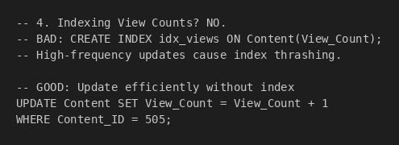

Partitioning:

5.You store billions of streaming logs. How would you partition the data for faster analytics, say by region or date?

Partitioning the streaming logs ensures that analytics queries only scan the relevant portion of data instead of the entire dataset. Range partitioning by timestamp (daily, weekly, or monthly) helps analytics engines quickly locate logs for a specific time window without scanning older partitions.
List partitioning by region isolates data geographically, allowing region-based dashboards or reports to operate on smaller partitions.
Combining date and region partitioning reduces query latency for massive log data and improves parallel scanning by analytical engines.

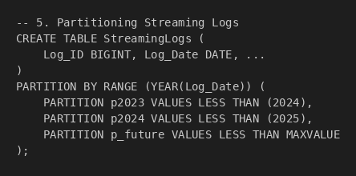

6.How would you partition user data to support regional data regulations and improve query latency for country-specific reports?

Geo-partitioning user data places each country’s users in separate partitions so queries for a specific region only touch that region’s data.
Storing users in country-based partitions helps comply with data-residency laws, ensuring customer information stays within legally allowed boundaries.
Partitioning also reduces scan size for regional reports—for example, India-specific analytics scan only the India partition instead of the full global user base.
This approach improves query latency, supports government regulations, and creates cleaner isolation of user segments.

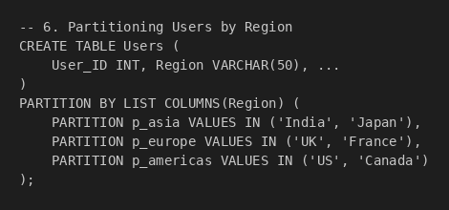

Normalization and Denormalization
7. How would you normalize data that links artists, albums, tracks, and genres in a music streaming app?
Normalization = Organizing database tables to remove redundancy and ensure data integrity
Normalized Schema Design: -
1. Artists Table (1NF, 2NF, 3NF)
Artists
- Artist_ID (PK)
- Name
- Birth_Date
- Nationality
No repeating groups, all attributes depend on Artist_ID only
2. Content Table (1NF, 2NF, 3NF)
Content
- Content_ID (PK)
- Title
- ReleaseDate
- Duration
- Rating
- Description
- View_Count
Each attribute depends solely on Content_ID
3. Genres Table (1NF, 2NF, 3NF)
Genres
- Genre_ID (PK)
- Genre_Name
Eliminates redundancy by storing each genre once
4. Junction Tables (Bridge Entities)
ContentArtists (Many-to-Many)
- Content_ID (PK, FK)
- Artist_ID (PK, FK)
- Role (Actor/Director/Writer)
ContentGenres (Many-to-Many)
- Content_ID (PK, FK)
- Genre_ID (PK, FK)
Benefits of This Normalized Design
- No Data Redundancy: Artist names and genres stored only once
- Update Anomalies Eliminated: Changing "Thriller" to "Psychological Thriller" updates one row, not thousands
- Insertion Flexibility: Can add new artists without requiring content assignment
- Deletion Safety: Removing content doesn't delete artist information
- Referential Integrity: Foreign keys maintain data consistency
Real-World Application from Case Study
Netflix manages content with multiple genres (e.g., "Horror, Thriller") and multiple artists per content. This normalized structure supports:
- Efficient genre-based categorization for browsing
- Artist search functionality across all content
- Clean metadata management for the 260+ shows released annually
8.For a daily recommendation engine, would you choose a normalized or denormalized schema? Justify your choice.
Denormalized Schema Design: -
Recommended Design:
UserRecommendationCache (Denormalized)
- User_ID
- Content_ID
- Content_Title
- Thumbnail_URL
- Genres (JSON: ["Action", "Thriller"])
- Artists (JSON: ["Actor1", "Actor2"])
- Recommendation_Score
- Duration
- Last_Updated
Justification:
1. Performance Requirements
Netflix Case Study: "80% of viewing is driven by recommendations"
- 300M+ users need recommendations instantly
- Must load in < 100ms
- Normalized = 5-6 JOINs = 500-2000ms
- Denormalized = Single table = 10-50ms

2. Query Comparison
Normalized (SLOW):
-- Multiple JOINs across 5 tables
SELECT c.Title, g.Genre_Name, a.Artist_Name
FROM Content c
JOIN ContentGenres cg ON c.Content_ID = cg.Content_ID
JOIN Genres g ON cg.Genre_ID = g.Genre_ID
-- Takes 500-2000ms at scale ❌
Denormalized (FAST):
-- Single table lookup
SELECT * FROM UserRecommendationCache
WHERE User_ID = ?
LIMIT 50;
-- Takes 10-50ms ✅

3. Trade-offs Analysis

Factor | Impact | Acceptable?
Storage Cost | Duplicate data for 300M users | Storage is cheap
Staleness | Updates every 4-6 hours | Users don't need real-time
Complexity | Batch refresh jobs | Manageable

4. Read-Heavy Workload
- Every homepage load = recommendation query
- Read:Write ratio = 1000:1
- Optimizing for reads is critical
Conclusion:
Choose DENORMALIZED because:
- Speed: 10-50x faster than normalized (critical for user experience)
- Scale: Handles 300M+ users efficiently
- Cost-Effective: Storage cost << compute cost
- Netflix Uses It: Case study mentions Cassandra (denormalized) for high-scale operations

Data Ingestion and Pipelines
9. Describe a pipeline that ingests live viewing data from smart TVs and mobile apps into an analytics dashboard.
Netflix uses a real-time streaming pipeline to handle billions of user interactions daily from 300M+ users.
Pipeline Architecture:
Smart TVs / Mobile Apps → Apache Kafka → Stream Processing (Flink / Spark) → Apache Cassandra → Data Lake (AWS S3) → Analytics Dashboard
Netflix's real-time streaming pipeline collects viewing data from smart TVs, mobile apps, and browsers in JSON format. Apache Kafka ingests millions of events/second across topics like viewing-events and user-interactions with fault-tolerant replication. Stream processing tools (Flink, Spark) perform deduplication, validation, and aggregation. Apache Cassandra stores billions of viewing history writes daily with sub-millisecond reads. The Data Lake (AWS S3) archives raw data in Parquet/Avro format to power ML recommendation engines. Finally, analytics dashboards (Grafana, Tableau) display concurrent viewers and system health with < 1 second latency, enabling real-time insights for 300M+ users.
Events Captured:
- Stream_Start: User begins watching content
- Play_Progress: Timestamp updates (every 10-30 seconds)
- Pause/Resume: User interaction events
- Stream_End: Completion or abandonment
- Quality_Change: Video resolution adjustments (4K → 1080p)
Data Format:
json
{
"user_id": 12345,
"content_id": 789,
"event_type": "play_progress",
"timestamp": "2025-12-13T10:30:45Z",
"device_type": "smart_tv",
"video_quality": "1080p",
"playback_position": 1250,
"ip_address": "192.168.1.1",
"region": "US"
}

Benefits:
Real-time insights (< 1s latency), massive scalability (300M+ users), and strong support for AI-driven recommendations, which account for ~80% of Netflix viewing.
This real-time ingestion pipeline allows Netflix to monitor viewer behavior instantly, improve content recommendations, detect issues early, and deliver a smooth viewing experience to millions of users worldwide.
10: What ingestion method would you use for third-party box office sales data that arrives weekly? Why?
Netflix would use Batch Ingestion (ETL) for third-party box office sales data.
Why Batch Ingestion?
- The data arrives only once a week, not continuously
- There is no need for real-time processing
- Batch jobs are cheaper, simpler, and easier to manage
How Netflix Implements It
- Scheduler: Apache Airflow
-Runs every Monday at 7 AM
- Ingestion: Data pulled via FTP / API
- Validation:
  - Remove duplicate records
  - Verify revenue figures
- Enrichment:
  - Match box office data with Netflix content catalog
- Transformation:
  - Calculate week-over-week trends
- Storage:
  - MySQL / CockroachDB → transactional storage
  - Data Warehouse → analytics & reporting
- Monitoring:
  - Email / Slack alerts for success or failure
Factor | Batch (ETL) | Streaming (Kafka)
Frequency | Weekly | Continuous
Cost | $50/month | $500/month
Complexity | Low | High
Validation | Comprehensive | Limited
Use Case | Weekly data | Real-time data
Since box office data arrives weekly and in moderate volume, batch ingestion is cheaper, simpler, and allows thorough validation.Streaming would be unnecessary—overkill for non-real-time data.

Sharding
11. During a global event like a concert live stream, millions of users access your platform. How would sharding help scale the user authentication system?
Sharding prevents database overload by splitting user data across multiple servers rather than relying on one central database.
- Partitioning Strategy: Netflix can shard users by Region (e.g., Shard Asia, Shard EU) to keep data close to the user. Within each region, data is further distributed using consistent hashing on the User ID.
- Routing Mechanism: When a user logs in, a Gateway service calculates the hash of their ID and routes the request directly to the specific shard holding their data.
- Benefit: This isolates traffic (a spike in Asia doesn't slow down the US), prevents hotspots, and allows linear scaling by simply adding more shards.
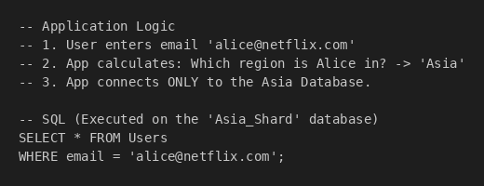
12. What are the risks or complications of sharding the 'Subscriptions' table by user region?
- Migration Complexity: Moving user data between regional shards when a user permanently relocates is risky and can disrupt service.
- Data Skew: Populations are uneven (e.g., millions in the US vs. thousands in a small country), leading to "hot shards" that are overworked while others sit idle.
- Cross-Shard Latency: Global operations (like checking for fraud across regions or generating worldwide reports) are slow because they must query multiple shards and aggregate the results.
- Operational Overhead: You must maintain schema consistency across all shards simultaneously; if a deployment fails on one shard, it causes global data inconsistency.
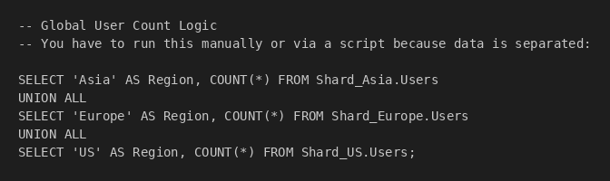

Data Lakes vs. Data Warehouses
13. Your platform collects raw clickstream data, user preferences, and transaction history. Which should go into a data lake and which into a data warehouse?
- Data Lake: Stores raw clickstream data (unstructured, high volume, logs) and user preferences (semi-structured, evolving). This allows flexibility for machine learning models that need raw, granular data.
- Data Warehouse: Stores transaction history (payments, invoices, plan changes). This data is structured, business-critical, and requires the strict consistency (ACID properties) of a warehouse for financial reporting and compliance.
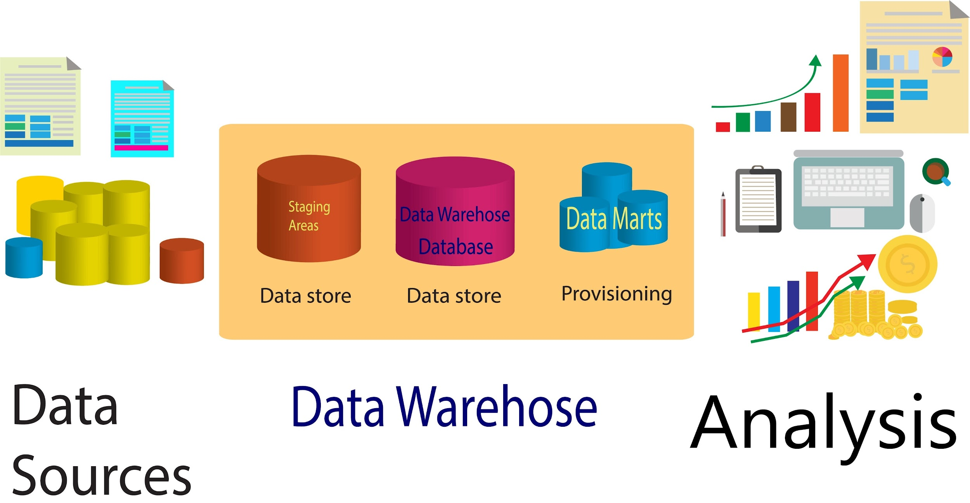
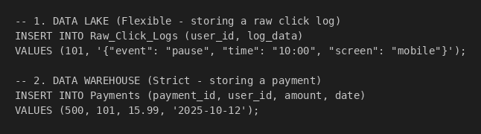
14. Explain how a data warehouse would be useful to generate monthly executive reports about subscriber churn and content engagement.
A data warehouse is optimized for OLAP (Online Analytical Processing), which allows efficient slicing and dicing of historical data. By aggregating cleaned data from various sources, executives can run complex queries (e.g., "Churn rate by Region vs. Device") without impacting the performance of the live application. It provides a "single source of truth" for consistent, accurate reporting over time.
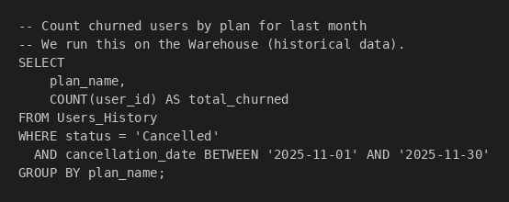

ETL:
15. Batch Aggregation ETL: Updating View Counts Question: The View_Count in the Content table needs to be updated nightly based on the raw activity in the UserContentInteraction table. How would you design a batch SQL job to perform this transformation and update without locking the entire table?
Answer: We perform an ELT (Extract, Load, Transform) operation within the database.
- Extract: We identify all new "watched" interactions from the UserContentInteraction table that occurred in the last 24 hours.
- Transform: We aggregate these records by Content_ID to calculate the total new views per movie/show.
- Load: We use a JOIN update to increment the View_Count in the Content table. This is more efficient than running individual updates for every user action.
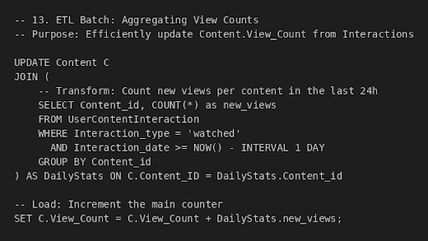

16. Ingestion ETL: Standardizing Data for Audit Logs Question: Data coming from different client devices (iOS, Android, Web) often has inconsistent naming conventions for security actions (e.g., "log-in", "LOGIN_SUCCESS", "signin"). How would you script an ETL transformation to clean this data before inserting it into the AuditLogs table?
Answer: We apply Data Standardization during the insertion process.
- Normalization: We use CASE statements or string functions (like UPPER) to map various incoming raw strings to the strict Action_Type allowed in our schema (e.g., 'Login', 'Download').
- Validation: We ensure that the User_ID exists in the Users table (Referential Integrity) before the insert occurs.
- Loading: The cleaned data is inserted into AuditLogs, ensuring the Action_Type column remains consistent for future querying.
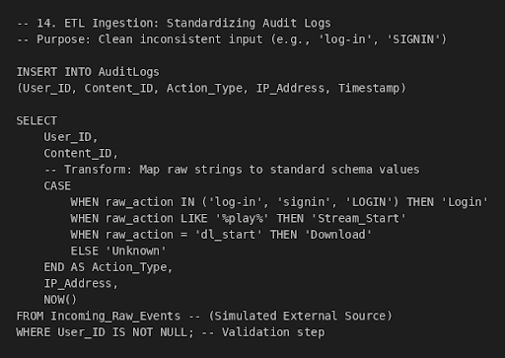

Other Relevant DBMS Topics
17. How would you handle versioning of TV show metadata (e.g., changes in synopsis, cast) over time for historical analysis? Use Slowly Changing Dimensions (SCD Type 2) or Temporal Tables.
- Mechanism: Instead of overwriting the old synopsis or cast list, the system inserts a new row for the update with valid timestamps (Start_Date, End_Date).
- Benefit: This preserves the full history, allowing analysts to query exactly what the metadata looked like at any specific point in the past to see how those changes influenced viewer engagement.

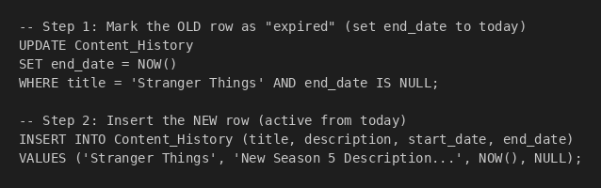
18. What DBMS features would you use to track and audit every time a user accesses or downloads a piece of copyrighted content?
- Immutable Logging: Use append-only audit tables to record every access event (User ID, Timestamp, Content ID, IP).
- Security: Implement WORM (Write Once, Read Many) storage policies so that once a log is written, it cannot be altered or deleted.
- Purpose: This provides a tamper-proof forensic trail strictly for legal compliance and fraud investigations.
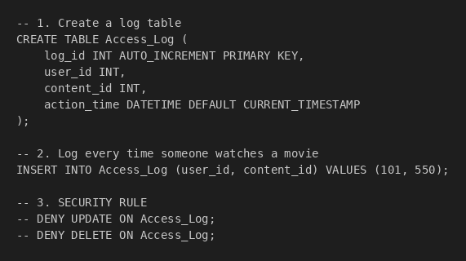
19. Your recommendation system needs fast access to user watch history and ratings. What database architecture or optimization techniques would you use?
- Caching: Use in-memory stores like Redis or Memcached to store the most recent watch history for instant retrieval (low latency).
- Materialized Views: Pre-compute and store complex aggregates (like "Top 3 Favorite Genres") so the system doesn't have to calculate them in real-time.
- Tiered Storage: Keep "hot" data (recent history) in fast databases and move "cold" data (years-old history) to cheaper, slower storage.
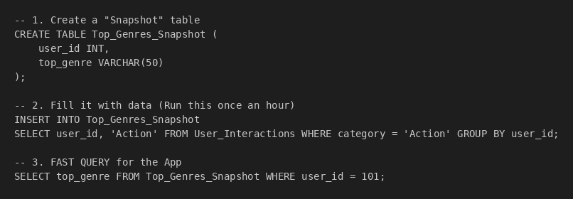
20. You’ve identified duplicate records for the same artist due to inconsistent ingestion from different sources. How would you detect and resolve these duplicates at scale?
- Standardization (Step 1): The ETL pipeline normalizes incoming data (fixing capitalization, trimming whitespace) to ensure formats are consistent.
- Detection (Step 2): Use Fuzzy Matching algorithms to calculate similarity scores between records that look similar but aren't identical (e.g., "J. Doe" vs. "John Doe").
- Resolution (Step 3): Merge the identified duplicates into a single "Golden Record" (the source of truth) while maintaining links to the original Source IDs for traceability.
